Crossed Octagrammic Cupola
# Source: AI Source: Provided by: [Data Path: Persons Table -> ID Column: 1, Name_En Column: Motasem Essam] -> From: [ChatGPT] on [7/25/2026]
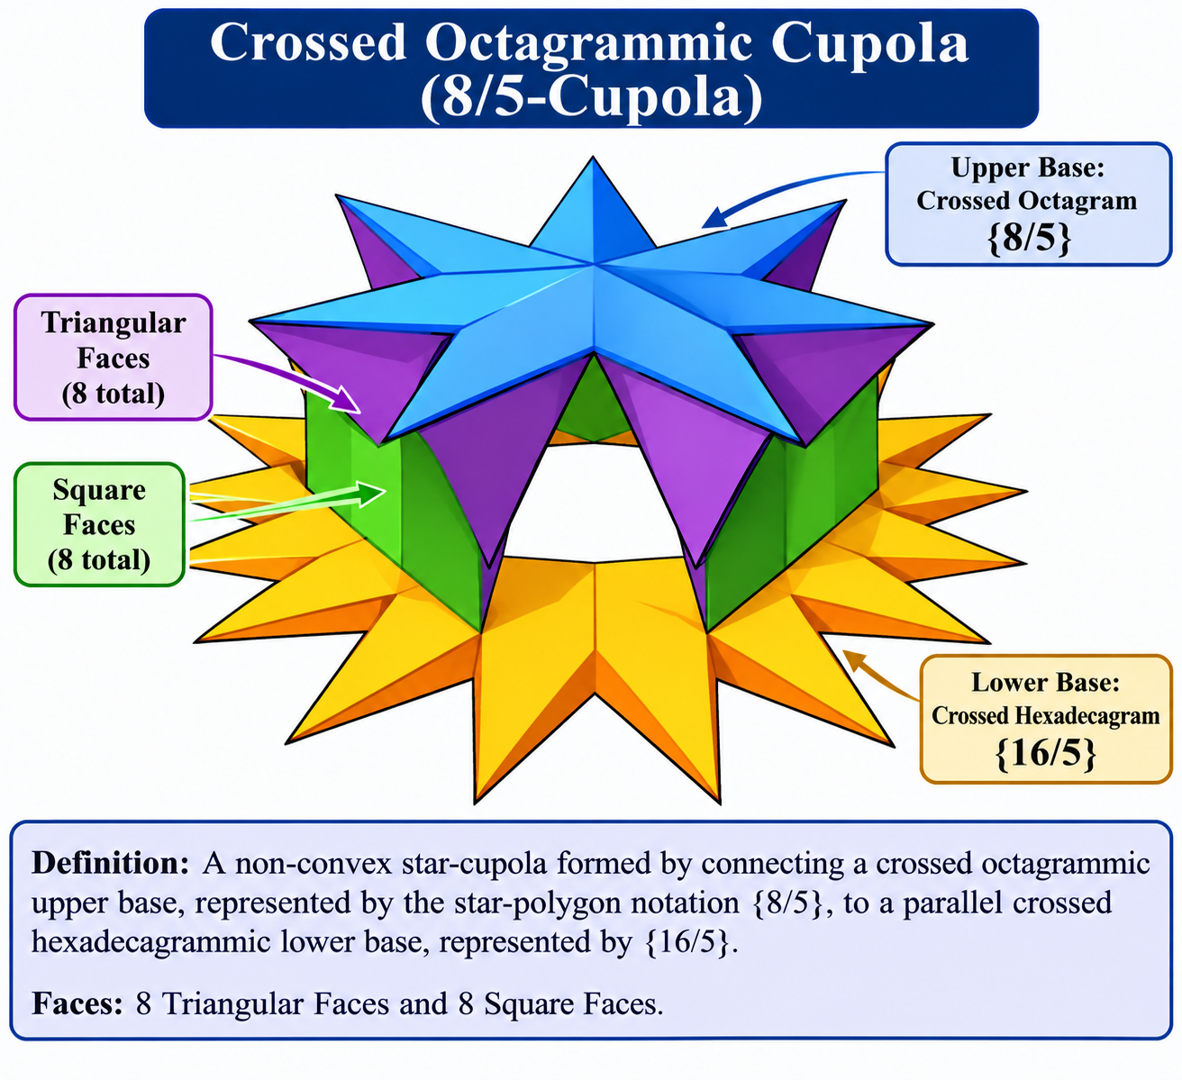

Definition
# Source: AI Source: Provided by: [Data Path: Persons Table -> ID Column: 1, Name_En Column: Motasem Essam] -> From: [ChatGPT] on [7/25/2026]
A Crossed Octagrammic Cupola, also known as an 8/5-Cupola or Retrograde Octagrammic Cupola, is a non-convex star-cupola formed by connecting a crossed octagrammic upper base to a parallel crossed hexadecagrammic lower base.
It is constructed using the star-polygon notation $\{8/5\}$ for the upper base and $\{16/5\}$ for the lower base. Its lateral structure consists of eight triangular faces and eight square faces. <Cite refs={["turn571125search3","turn571125search12","turn571125search10"]}/>
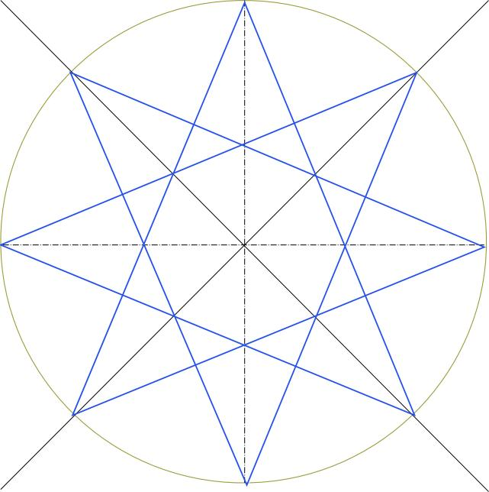

Geometric Structure
# Source: AI Source: Provided by: [Data Path: Persons Table -> ID Column: 1, Name_En Column: Motasem Essam] -> From: [ChatGPT] on [7/25/2026]
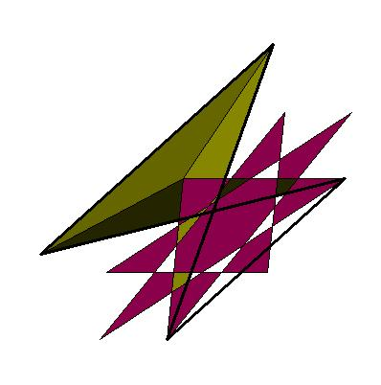
The Crossed Octagrammic Cupola consists of:
- Upper Base: A crossed octagram represented by the star-polygon notation $\{8/5\}$.
- Lower Base: A crossed hexadecagram represented by the star-polygon notation $\{16/5\}$.
- Triangular Faces: Eight equilateral triangular lateral faces.
- Square Faces: Eight square lateral faces.
- Crossed Arrangement: The lateral faces connect the two bases according to the crossed octagram's vertex sequence.
<Cite refs={["turn571125search3","turn571125search10"]}/>

Face Composition
# Source: AI Source: Provided by: [Data Path: Persons Table -> ID Column: 1, Name_En Column: Motasem Essam] -> From: [ChatGPT] on [7/25/2026]
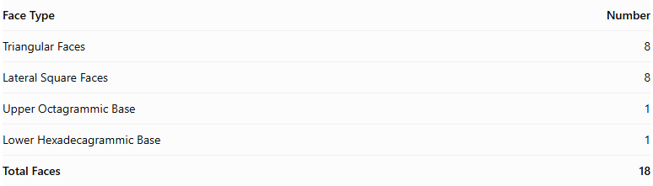
Face Type | Number
Triangular Faces | 8
Lateral Square Faces | 8
Upper Octagrammic Base | 1
Lower Hexadecagrammic Base | 1
Total Faces | 18
The two bases are crossed star polygons, while the sixteen lateral faces form the connecting structure. <Cite refs={["turn571125search3","turn571125search10"]}/>

Mathematical Properties
# Source: AI Source: Provided by: [Data Path: Persons Table -> ID Column: 1, Name_En Column: Motasem Essam] -> From: [ChatGPT] on [7/25/2026]
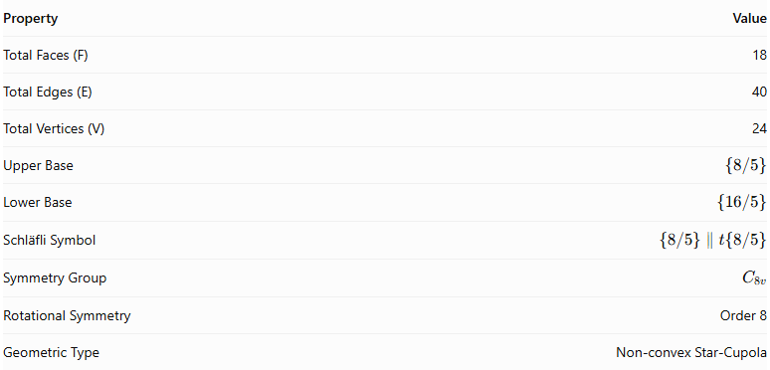
Property | Value
Total Faces (F) | 18
Total Edges (E) | 40
Total Vertices (V) | 24
Upper Base | $$\{8/5\}$$
Lower Base | $$\{16/5\}$$
Schläfli Symbol | $$\{8/5\}∥t\{8/5\}$$
Symmetry Group | $$C_{8v}$$
Rotational Symmetry | Order 8
Geometric Type | Non-convex Star-Cupola
<Cite refs={["turn571125search3","turn571125search10"]}/>
General Cupola Formulas:
$$F=2n+2, E=5n, V=3n$$
For $n=8$:
$$F=18, E=40, V=24$$
Euler's Polyhedron Formula:
$$V-E+F=2$$
$$24-40+18=2$$

Geometric Characteristics
# Source: AI Source: Provided by: [Data Path: Persons Table -> ID Column: 1, Name_En Column: Motasem Essam] -> From: [ChatGPT] on [7/25/2026]
- Non-Convex Structure: Its crossed star-polygon bases produce a non-convex geometric arrangement.
- Crossed Octagrammic Upper Base: The upper base follows the $\{8/5\}$ vertex sequence, connecting every fifth vertex.
- Crossed Hexadecagrammic Lower Base: The lower base follows the $\{16/5\}$ star-polygon sequence.
- Eightfold Rotational Symmetry: Its structure repeats after a rotation of ${45}^{∘}$.
- Alternating Lateral Faces: Eight triangular faces and eight square faces form the lateral structure.
- Relationship to Octagrammic Cupola: It differs from the ordinary Octagrammic Cupola $\{8/3\}$ because it uses a different vertex-connection pattern.

Constructing Crossed Octagrammic Cupola in Solid Geometry

Geometric Instruments Used
# Source: AI Source: Provided by: [Data Path: Persons Table -> ID Column: 1, Name_En Column: Motasem Essam] -> From: [ChatGPT] on [7/25/2026]
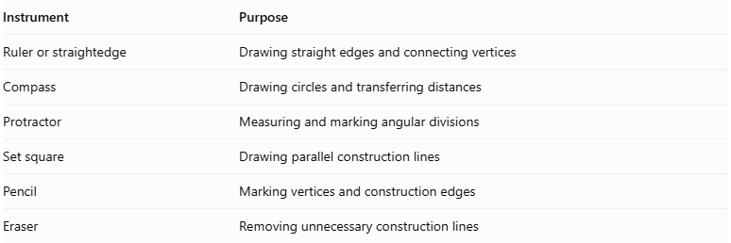
Instrument | Purpose
Ruler or straightedge | Drawing straight edges and connecting vertices
Compass | Drawing circles and transferring distances
Protractor | Measuring and marking angular divisions
Set square | Drawing parallel construction lines
Pencil | Marking vertices and construction edges
Eraser | Removing unnecessary construction lines
Construction method: Instrument-based geometric construction using geometric instruments, angular measurements, and geometric relationships. It does not use coordinate-based construction.

Instrument-Based Construction Procedures

Constructing the Upper Crossed Octagram
# Source: AI Source: Provided by: [Data Path: Persons Table -> ID Column: 1, Name_En Column: Motasem Essam] -> From: [ChatGPT] on [7/25/2026]
- Draw a circle using a compass.
- Mark eight equally spaced points around its circumference.
- Number the vertices consecutively from 1 to 8.
- Connect every vertex to the vertex five positions ahead, wrapping around after vertex 8.
- Follow the connection sequence:
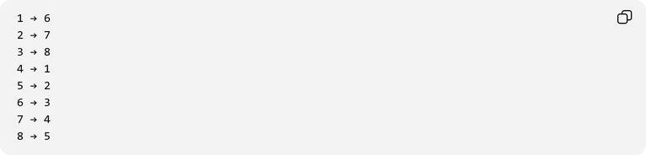
1 → 6
2 → 7
3 → 8
4 → 1
5 → 2
6 → 3
7 → 4
8 → 5
- Complete the upper star polygon $\{8/5\}$.

Constructing the Lower Crossed Hexadecagram
# Source: AI Source: Provided by: [Data Path: Persons Table -> ID Column: 1, Name_En Column: Motasem Essam] -> From: [ChatGPT] on [7/25/2026]
- Draw a second circle for the lower base.
- Mark sixteen equally spaced points around its circumference.
- Number the vertices consecutively from 1 to 16.
- Connect every vertex to the vertex five positions ahead, wrapping around after vertex 16.
- Complete the lower star polygon $\{16/5\}$.

Positioning the Two Bases
# Source: AI Source: Provided by: [Data Path: Persons Table -> ID Column: 1, Name_En Column: Motasem Essam] -> From: [ChatGPT] on [7/25/2026]
- Represent the upper and lower bases as parallel planes.
- Position the crossed octagram above the crossed hexadecagram.
- Align their orientations according to the crossed octagrammic cupola arrangement.
- Maintain eight-fold rotational symmetry around the central axis.

Constructing the Lateral Faces
# Source: AI Source: Provided by: [Data Path: Persons Table -> ID Column: 1, Name_En Column: Motasem Essam] -> From: [ChatGPT] on [7/25/2026]
- Connect the upper and lower base vertices according to the crossed octagrammic cupola's face-adjacency pattern.
- Construct eight triangular lateral faces.
- Construct eight square lateral faces.
- Arrange the lateral faces to preserve the crossed star-cupola structure.
- Check the connections carefully to avoid unintended edges or gaps.

Completing the Three-Dimensional Representation
# Source: AI Source: Provided by: [Data Path: Persons Table -> ID Column: 1, Name_En Column: Motasem Essam] -> From: [ChatGPT] on [7/25/2026]
- Darken the visible edges.
- Use dashed lines for hidden edges where appropriate.
- Preserve the crossed appearance of both star-polygon bases.
- Check the eight-fold rotational symmetry.
- Verify the lateral-face arrangement and overall geometric structure.
Construction accuracy note: A regular octagon and regular 16-gon can both be constructed exactly using a compass and unmarked straightedge. The star polygons are obtained by connecting every fifth vertex; no coordinate-based construction is required.

Key Points
# Source: AI Source: Provided by: [Data Path: Persons Table -> ID Column: 1, Name_En Column: Motasem Essam] -> From: [ChatGPT] on [7/25/2026]
- Alternative Name: 8/5-Cupola.
- Upper Base: Crossed Octagram $\{8/5\}$.
- Lower Base: Crossed Hexadecagram $\{16/5\}$.
- Lateral Faces: 8 Triangles and 8 Squares.
- Total Faces: 18.
- Total Edges: 40.
- Total Vertices: 24.
- Rotational Symmetry: Order 8.
- Classification: Non-convex Star-Cupola.

Main Classification
# Source: AI Source: Provided by: [Data Path: Persons Table -> ID Column: 1, Name_En Column: Motasem Essam] -> From: [ChatGPT] on [7/25/2026]
Solid Geometry
└── Types of Solids
└── Star-Cupola
└── Types of Star-Cupola
└── Crossed Octagrammic Cupola

Conclusion
# Source: AI Source: Provided by: [Data Path: Persons Table -> ID Column: 1, Name_En Column: Motasem Essam] -> From: [ChatGPT] on [7/25/2026]
The Crossed Octagrammic Cupola is a non-convex star-cupola characterized by its crossed octagrammic upper base, crossed hexadecagrammic lower base, and alternating triangular and square lateral faces. It has 18 faces, 40 edges, and 24 vertices, with eightfold rotational symmetry.
Important distinction: The Crossed Octagrammic Cupola $\{8/5\}$ is different from the ordinary Octagrammic Cupola $\{8/3\}$. Both belong to the star-cupola family, but they use different vertex-connection patterns. <Cite refs={["turn571125search3","turn571125search12"]}/>

